CyberShield
AI-Powered Phishing Website Detection & Cybersecurity Analytics Platform

IBM Data Analytics Academic Internship – Capstone Project

235,795  Dataset Records | 100,945  Phishing URLs | 134,850  Legitimate URLs | 99.76%  Reported URL Model F1

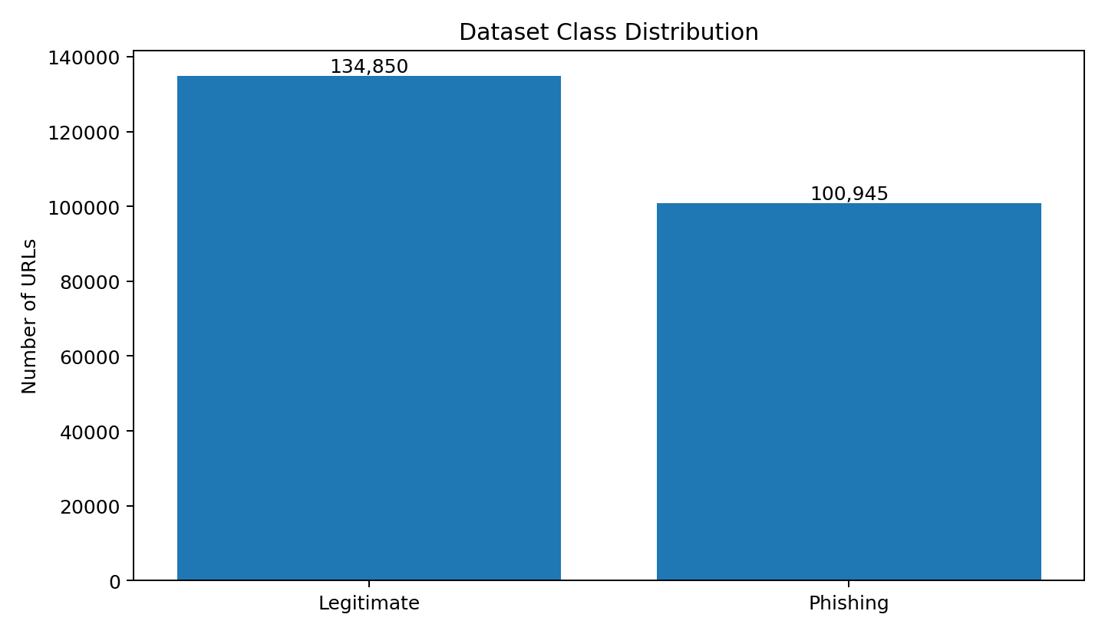
Prepared for academic submission | September 2026

1. Executive Summary
CyberShield is an end-to-end data analytics and machine learning platform for identifying phishing websites from URL and security-related indicators. The project was developed as part of the IBM Data Analytics Academic Internship and combines data preparation, exploratory data analysis, feature-based machine learning, model evaluation, visualization, and interactive deployment.
The system uses the PhiUSIIL Phishing URL (Website) dataset from the UCI Machine Learning Repository. The dataset contains 235,795 records: 134,850 legitimate URLs and 100,945 phishing URLs, with 54 features and no missing values reported by UCI. The project trains a Random Forest classifier and provides a Streamlit dashboard with dataset analytics, model performance, cybersecurity insights, and a live URL analyzer.
A second, URL-only feature track is used for the interactive screening workflow so that a user can enter a URL and receive a classification and risk interpretation without requiring the original webpage source-code features. The application parses the URL as text and does not open the submitted website.

Project Highlights
- Large-scale phishing classification using 235,795 labeled URL records.
- Random Forest based supervised machine-learning pipeline.
- Exploratory analysis of class balance, HTTPS usage, lexical URL characteristics, correlations, and feature importance.
- Interactive Streamlit dashboard with Home, URL Analyzer, Security Analytics, Model Performance, Cybersecurity Insights, and About sections.
- Live URL screening based on extracted URL characteristics; the application does not initiate network requests to the entered URL.
- Public GitHub repository and Streamlit deployment for demonstration and evaluation.

2. Problem Statement
Phishing websites imitate trusted online services to deceive users into entering credentials, financial information, or other sensitive data. Manual inspection of URLs is difficult because attackers can manipulate domain structure, URL length, subdomains, symbols, redirects, and other characteristics.
The project therefore addresses the following problem: how can data analytics and machine learning be used to identify phishing URLs from measurable security and lexical characteristics and present the result through an accessible application?

3. Objectives
- Collect and understand a labeled phishing URL dataset.
- Clean and prepare the data for supervised machine learning.
- Perform exploratory data analysis to identify meaningful security patterns.
- Build a classification model that distinguishes phishing from legitimate URLs.
- Evaluate the model using classification metrics, with emphasis on F1-score.
- Identify influential URL/security features using feature importance analysis.
- Develop an interactive dashboard for analytics and practical URL screening.
- Deploy the application publicly and maintain the complete source code in GitHub.

4. Dataset Description
The project uses the PhiUSIIL Phishing URL (Website) dataset, Dataset ID 967, from the UCI Machine Learning Repository. UCI reports 235,795 instances and 54 features, consisting of 134,850 legitimate URLs and 100,945 phishing URLs. The repository also reports no missing values. Label 1 represents legitimate URLs and label 0 represents phishing URLs.
Dataset Property | Value | Purpose
Source | UCI Machine Learning Repository | Reliable academic dataset source
Dataset ID | 967 | Dataset identification
Instances | 235,795 | Large-scale supervised learning
Features | 54 | URL and webpage-derived security indicators
Legitimate | 134,850 (57.2%) | Class 1
Phishing | 100,945 (42.8%) | Class 0
Missing values | None reported by UCI | Simplifies preprocessing

Representative Features
- URLLength – length of the complete URL.
- DomainLength – length of the domain portion.
- IsDomainIP – whether an IP address is used instead of a conventional domain.
- TLD – top-level-domain information.
- URLSimilarityIndex – similarity-related URL indicator.
- CharContinuationRate – character continuation pattern.
- TLDLegitimateProb – probability-related TLD indicator.
- Additional URL, domain, webpage, and security indicators available in the full dataset.

5. Methodology
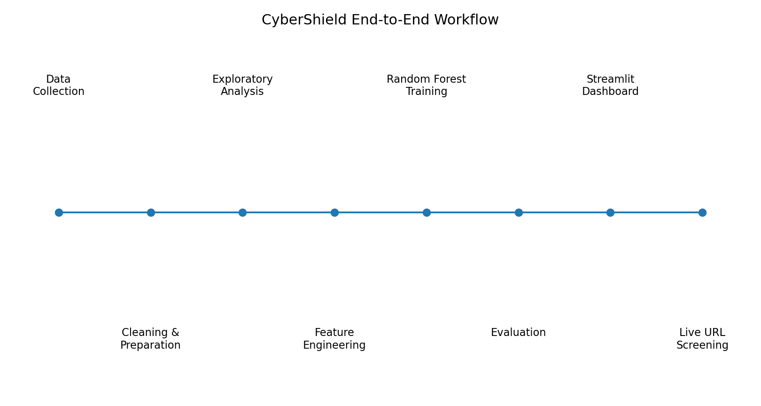

5.1 Data Preparation
- Loaded the CSV dataset using Pandas.
- Inspected dimensions, data types, class labels, and missing values.
- Checked for duplicate records and inconsistent data types.
- Separated target labels from predictive features.
- Prepared numerical/categorical information for model training.
- Stored the trained model and supporting feature metadata as serialized files for application use.

5.2 Exploratory Data Analysis
- Measured the distribution of phishing and legitimate records.
- Compared HTTPS usage across the two classes.
- Analyzed URL and lexical structure distributions.
- Examined feature relationships and correlations.
- Generated feature-importance views to understand which variables contribute to classification.

5.3 Machine Learning
A Random Forest Classifier was selected as the main supervised learning algorithm. The model learns decision rules from multiple decision trees and combines their outputs for classification. The dataset is divided into training and testing portions so that the final model can be evaluated on unseen records.
Two practical tracks are represented in the application: a full-feature research/benchmark track using the available dataset attributes, and a URL-only screening track intended for interactive user input.

5.4 Evaluation
The deployed dashboard reports an F1-score of 99.76% for the URL model. F1-score combines precision and recall and is useful for classification tasks where both false positives and false negatives matter.
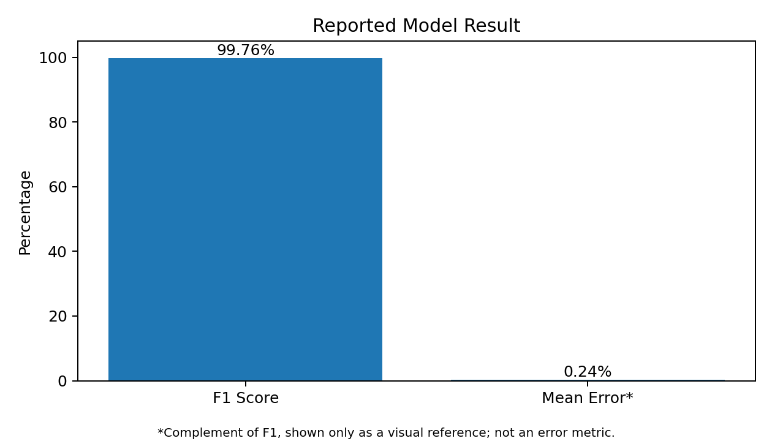
Note: the displayed F1-score is the project result on the implemented evaluation setup; it should not be interpreted as a guarantee of performance on unseen real-world phishing campaigns.

6. Dashboard & Application Design
CyberShield is designed as an analytics hierarchy rather than a single prediction screen. The dashboard follows the logic of moving from what is happening, to how it changes, why it happens, what could go wrong, and what action can be taken.
Level | Dashboard Component | Purpose
Level 1 – KPIs | Home | Dataset size, class counts, model headline metric
Level 2 – Trends | Security Analytics | Class distribution, HTTPS usage, lexical distributions
Level 3 – Drivers | Feature Analysis | Feature relationships and influential security indicators
Level 4 – Risk | URL Analyzer | Classification, probability/risk interpretation, suspicious indicators
Level 5 – Action | Cybersecurity Insights | Practical security guidance and interpretation

Main Application Pages
- Home – project overview, dataset KPIs, phishing explanation, and academic workflow.
- URL Analyzer – accepts a URL as text and performs feature extraction and classification.
- Security Analytics – visual exploration of classes, HTTPS usage, lexical structure, and relationships.
- Model Performance – presents evaluation results and feature-importance information.
- Cybersecurity Insights – translates model findings into understandable security observations.
- About Project – project synopsis, technology stack, dataset attribution, and methodology.

7. Technology Stack
Layer | Technology | Purpose
Programming | Python | Core development language
Data Handling | Pandas, NumPy | Data loading, cleaning, transformation
Machine Learning | Scikit-learn | Random Forest classification and evaluation
Visualization | Matplotlib, Seaborn | Charts and analytical visualization
Application | Streamlit | Interactive web dashboard
Model Storage | Joblib / serialized files | Reuse trained models and metadata
Version Control | Git & GitHub | Source-code management and public repository
Deployment | Streamlit Community Cloud | Public application deployment

8. Project File Structure
CyberShield/
├── app/
│ └── CyberShield.py
├── data/
│ └── phishing_dataset.csv
├── model/
│ ├── phishing_model.pkl
│ ├── url_model.pkl
│ ├── feature_columns.pkl
│ ├── url_feature_columns.pkl
│ ├── feature_importance.csv
│ ├── url_feature_importance.csv
│ ├── model_metrics.pkl
│ └── url_model_metrics.pkl
├── notebooks/
│ └── CyberShield_Analysis.ipynb
├── reports/
│ └── project_summary.md
├── requirements.txt
├── train_models.py
└── README.md

9. Live URL Analysis & Safety Design
The URL Analyzer is designed for safe lexical screening. A submitted URL is treated as a string and its structural characteristics are extracted for model input. The application explicitly avoids opening the target website, sending requests to it, or executing remote content. This reduces the risk of interacting with a potentially malicious site during demonstration.
- Input: a website URL entered by the user.
- Processing: URL parsing and extraction of supported lexical/security indicators.
- Prediction: Random Forest classification using the URL-only model.
- Output: phishing/legitimate classification, probability/risk interpretation, and supporting indicators.
- Demonstration examples: legitimate domains, suspicious IP-based URLs, and phishing-style spoof URLs.

10. Results & Key Insights
- The dataset contains a substantial number of both phishing and legitimate records, allowing supervised classification.
- The class distribution is approximately 42.8% phishing and 57.2% legitimate.
- HTTPS usage is an important analytical dimension, but HTTPS alone does not prove that a website is legitimate.
- URL structure, domain characteristics, similarity measures, and other lexical/security indicators provide useful information for classification.
- The deployed URL model reports an F1-score of 99.76% on the project's evaluation setup.
- The dashboard converts model output into a user-facing cybersecurity screening workflow instead of presenting only a raw machine-learning prediction.

11. Practical Use Cases
- Educational cybersecurity demonstrations and awareness training.
- Initial screening of suspicious URLs before a user investigates them further.
- Data-analytics demonstration for security operations concepts.
- Academic exploration of phishing indicators and supervised classification.
- Prototype foundation for a larger URL reputation or browser-security system.

12. Limitations & Future Scope
- The current system is a machine-learning screening prototype, not a replacement for commercial threat-intelligence or browser security systems.
- Real-world phishing campaigns evolve continuously, so model performance can change when attackers introduce new URL patterns.
- The live analyzer relies on features that can be derived from the submitted URL; it does not crawl or inspect the live webpage.
- Future versions could add external threat-intelligence feeds, domain-age information, DNS/WHOIS signals, screenshot-based webpage analysis, and continuous retraining.
- A future version could include model explainability at the individual URL level so that each prediction is accompanied by the strongest contributing indicators.
- Testing on newer, independently collected phishing campaigns would provide a stronger measure of generalization.

13. Conclusion
CyberShield demonstrates a complete data-analytics-to-deployment workflow for cybersecurity. The project begins with a large labeled phishing dataset, applies data preparation and exploratory analysis, trains a Random Forest classifier, evaluates the model, and exposes the results through an interactive Streamlit application. The final system combines analytics, machine learning, visualization, and practical URL screening in a single academic project.
The project also demonstrates the core learning outcomes of the IBM Data Analytics Academic Internship: understanding data, preparing data, applying AI/ML to an analytical problem, interpreting results, and converting the analysis into a usable business/security-oriented solution.

14. References
- Prasad, A. & Chandra, S. (2024). PhiUSIIL Phishing URL (Website) Dataset. UCI Machine Learning Repository, Dataset ID 967. DOI: 10.1016/j.cose.2023.103545.
- UCI Machine Learning Repository. PhiUSIIL Phishing URL (Website) dataset documentation.
- Scikit-learn documentation – Random Forest classification and model evaluation.
- Streamlit documentation – application deployment and interactive data apps.
- Project GitHub repository: https://github.com/Anushree-C-baraker/CyberShield-Phishing-Detection
- Live application: https://cybershield-phishing-detection.streamlit.app
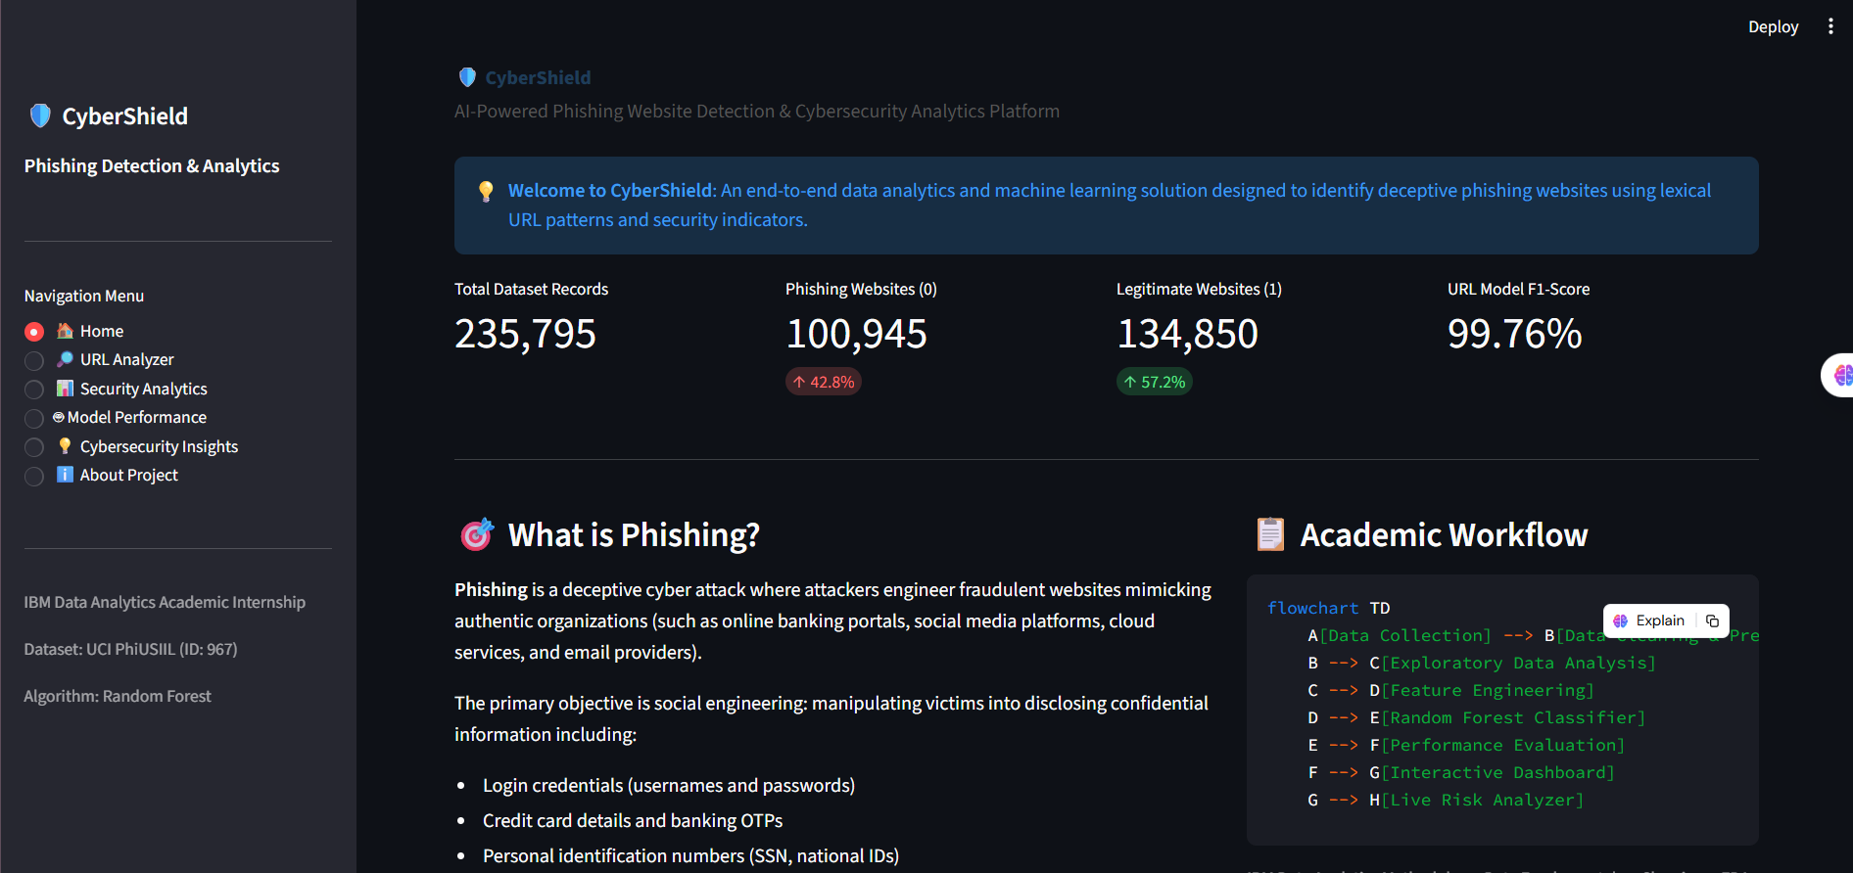
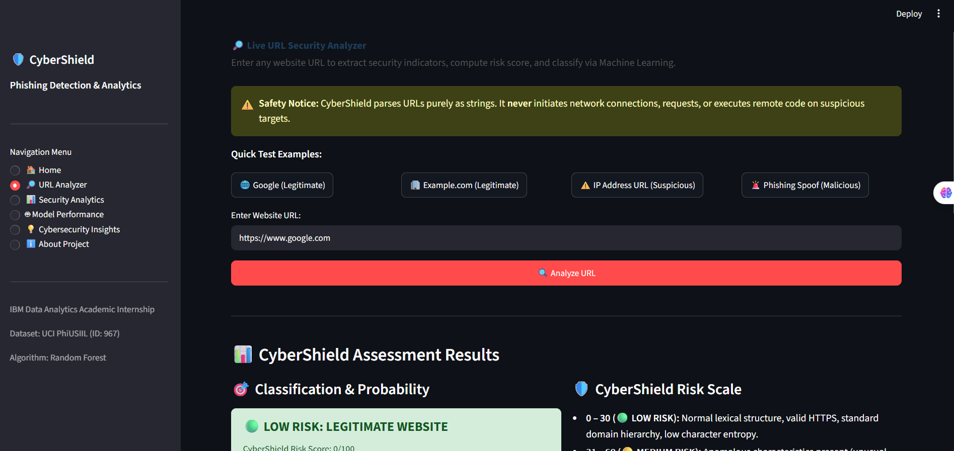

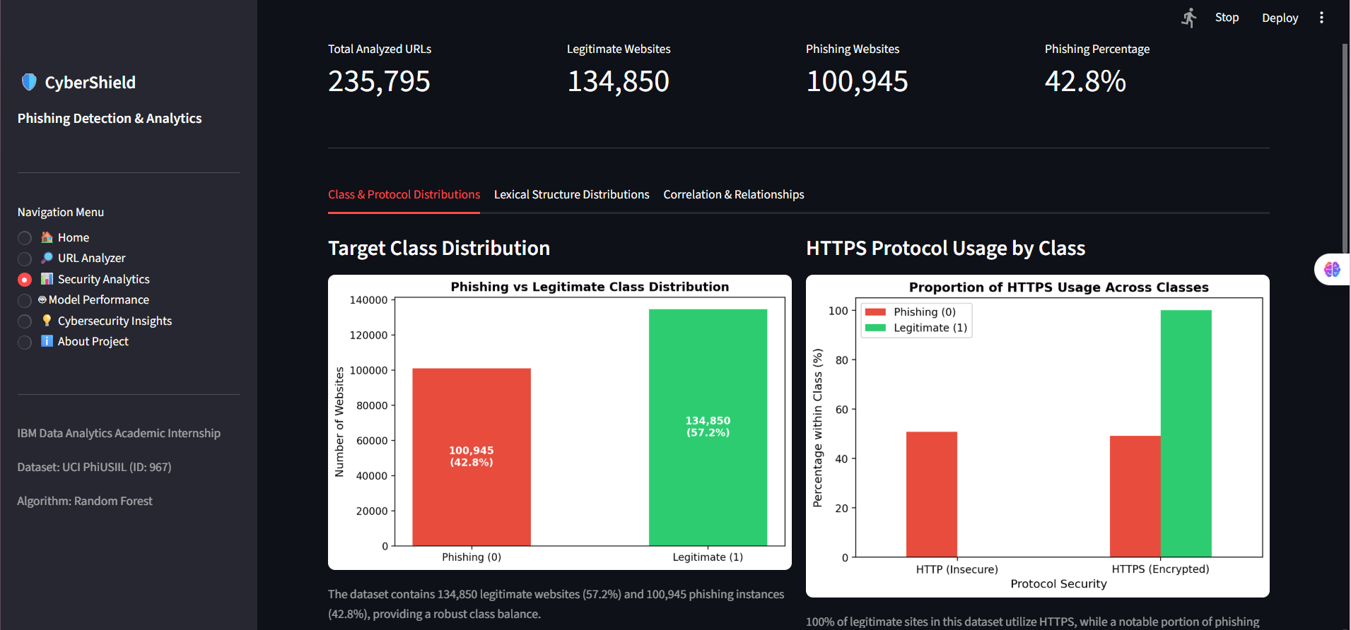

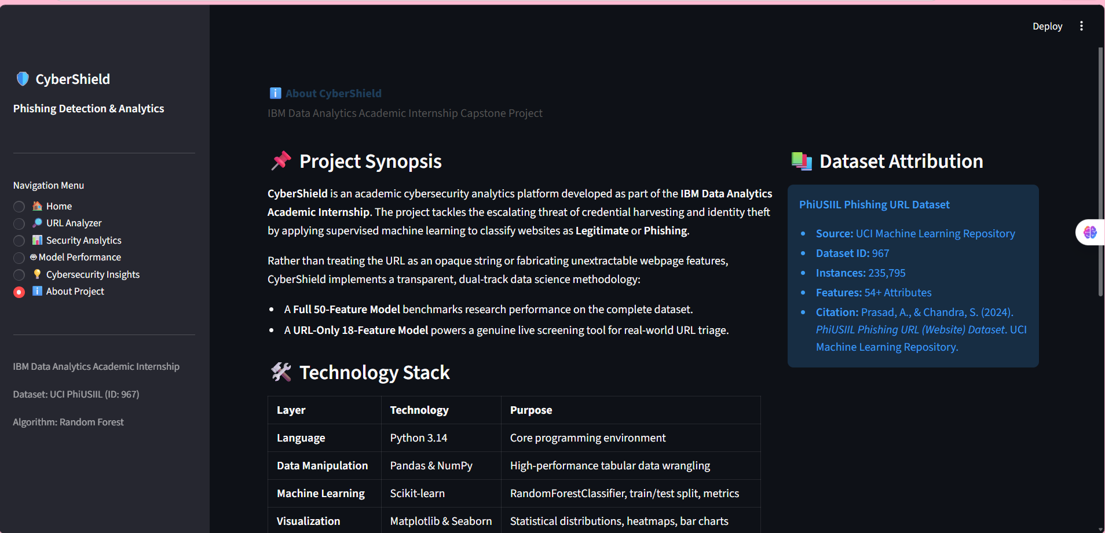

End of Report

